Download link: [www.kidsbits.net/Down/KidsBlock Desktop 1.1.3.dmg](http://www.kidsbits.net/Down/KidsBlock Desktop 1.1.3.dmg)

1. Download kidsblock，as shown below;

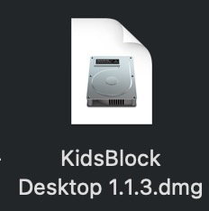

1. Double-click KidsBlock icon，then drag 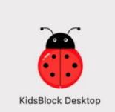 to the **Applications** folder.

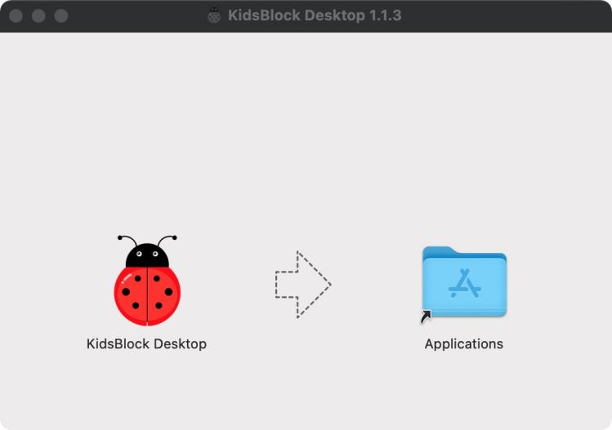

After the installation is finished, you will view KidsBlock icon.

